ECE 6810 Assignment No. 2 Zeyu Liu G24910689

- Download TIMIT Speech data file from Blackboard.

- Play the TIMIT wave file with a media player.

- Write a matlab code to read the wave file into a vector x.
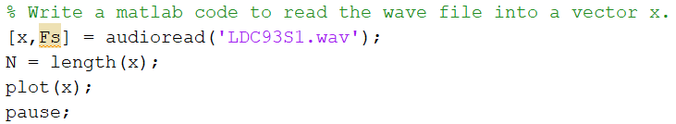
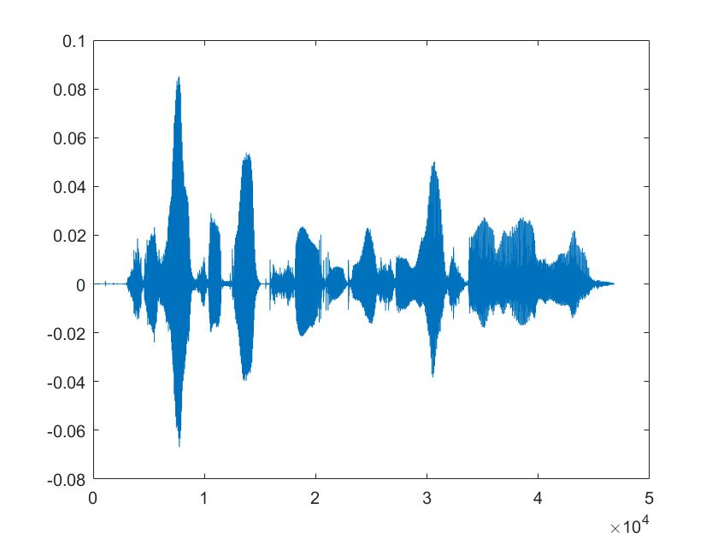

- Divide the vector x into five segments and plot them.
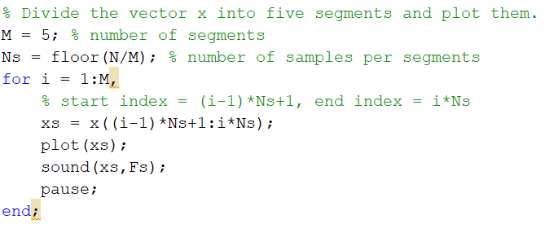

Part 1:
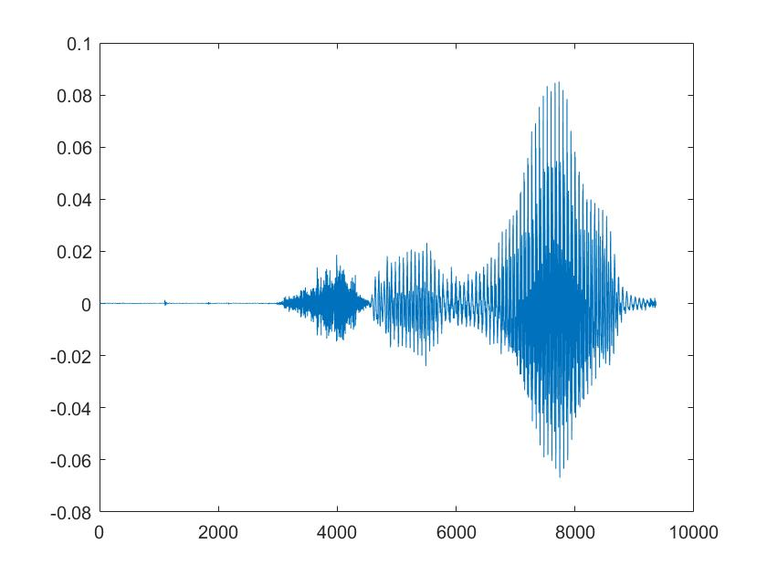

Part 2:

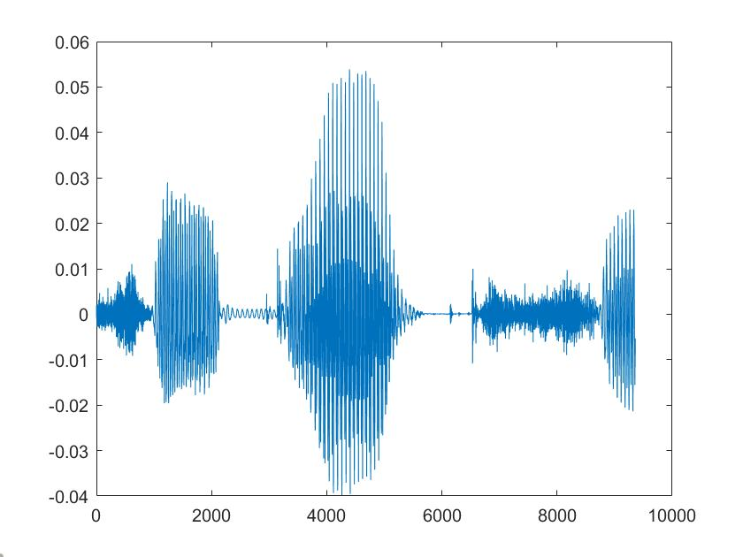

Part 3:

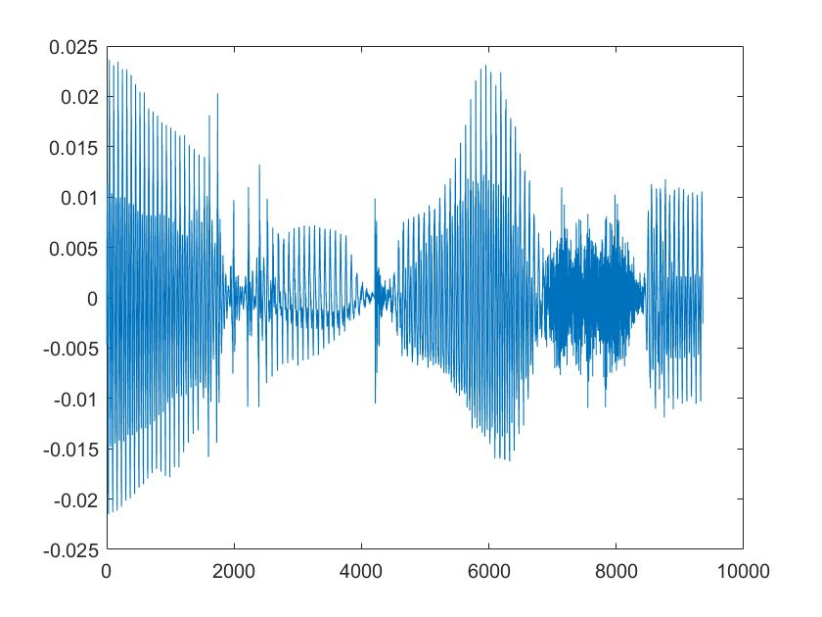

Part 4:

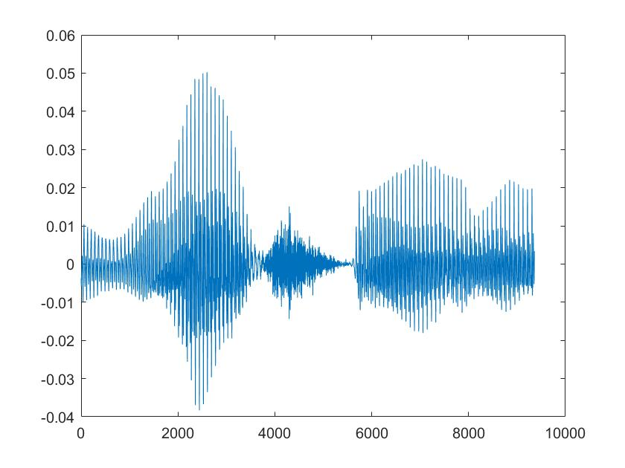

Part 5:

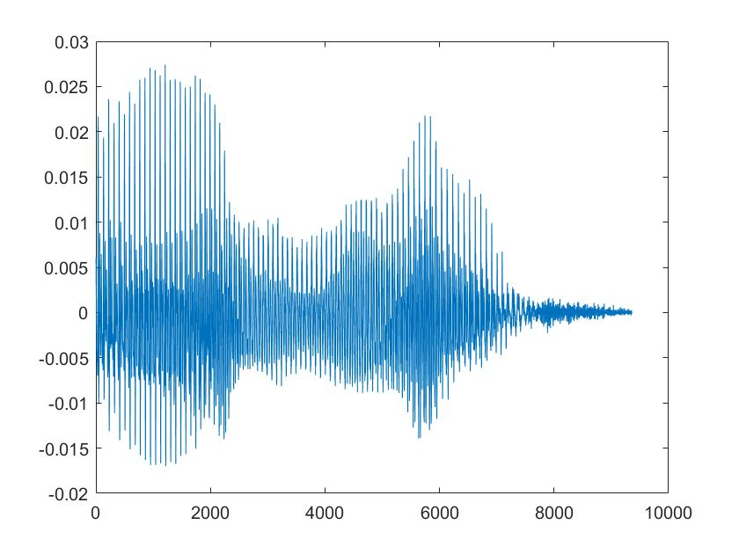

- Manually identify silence, voiced and unvoiced speech.

I mark them in the figures below.

Part 1:

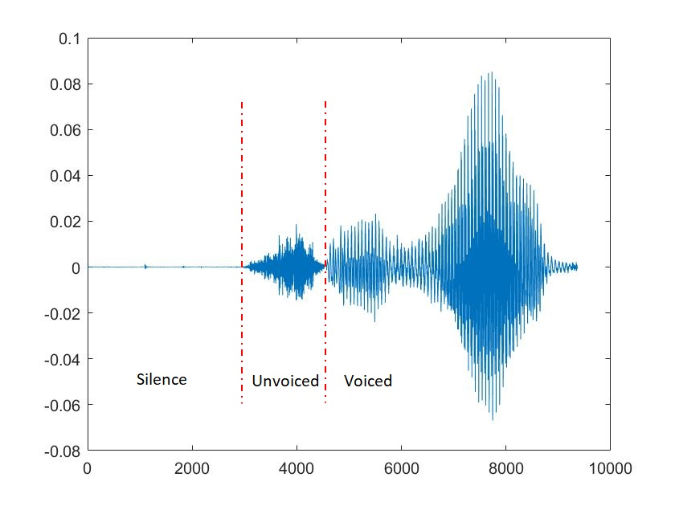

Part 2:

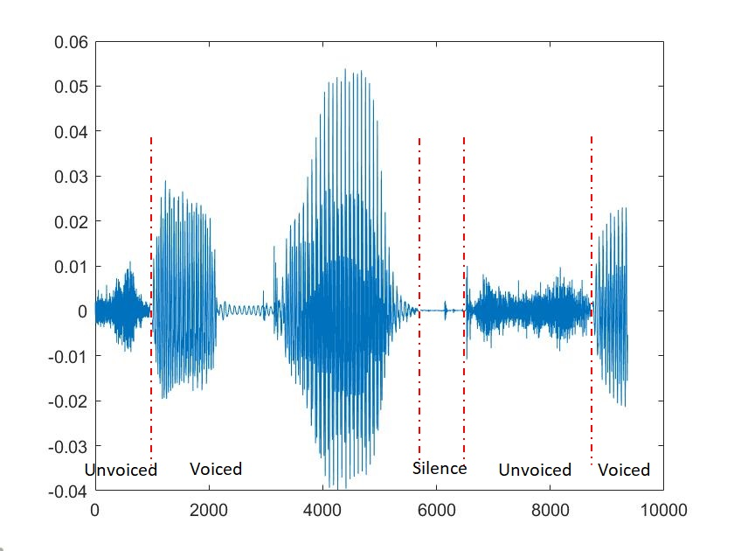

Part 3:

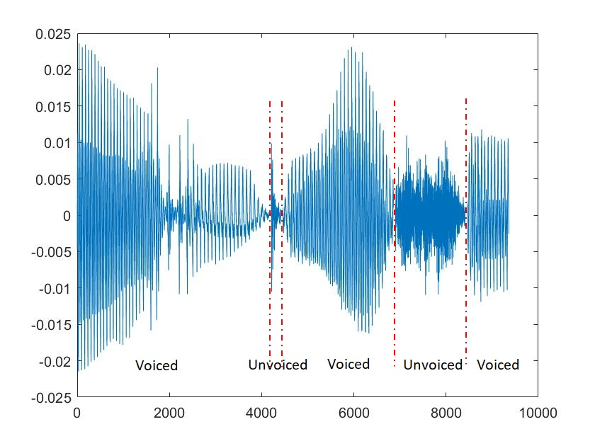

Part 4:

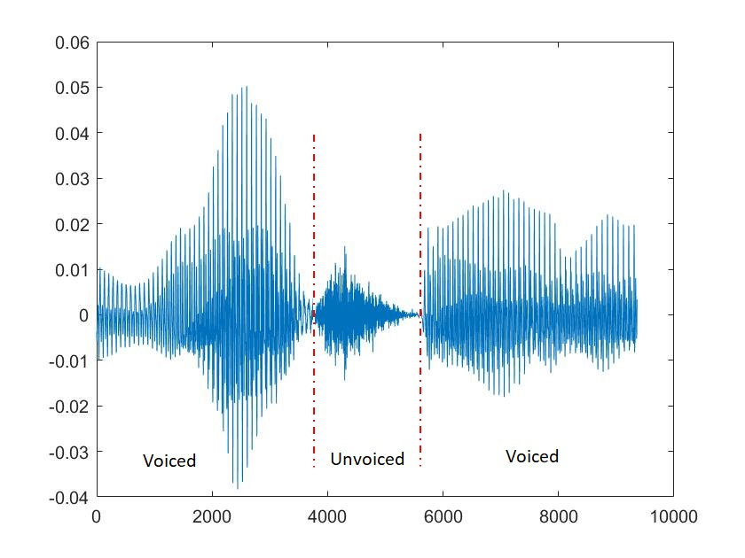

Part 5:

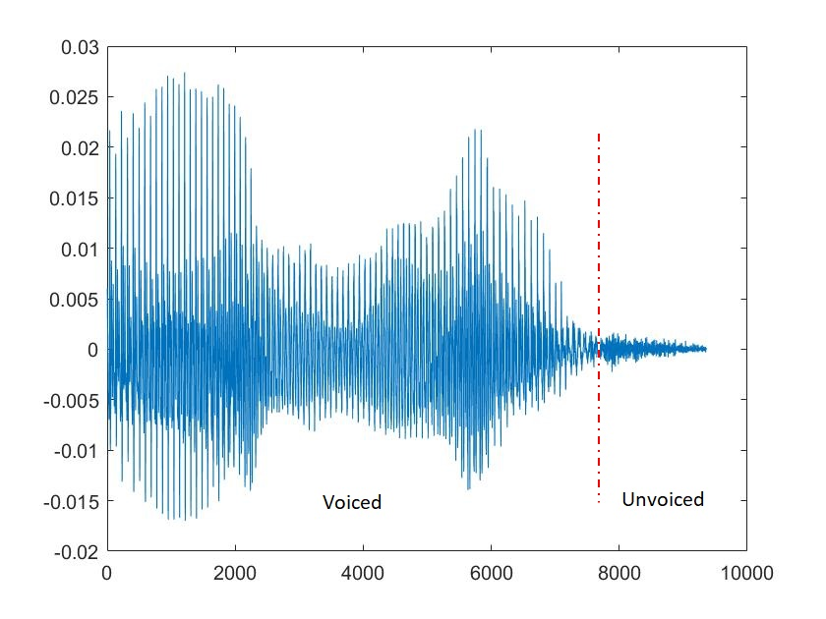

- Write a matlab code to play the vector x (sampling frequency = 16 KHz).

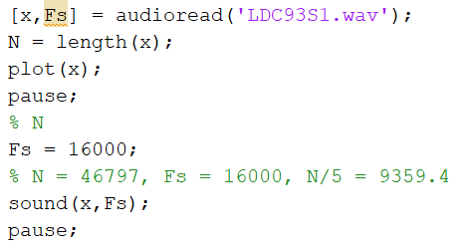

- Divide the speech file into 20ms segments (320 samples each), and compute periodogram of each segment using the program you wrote in Homework 1. Then compute spectrogram by constructing an image made of set of periodograms. Display the negative image in log-scale.

Because there are about 146 segments, I use the first segments to work, as same as others.
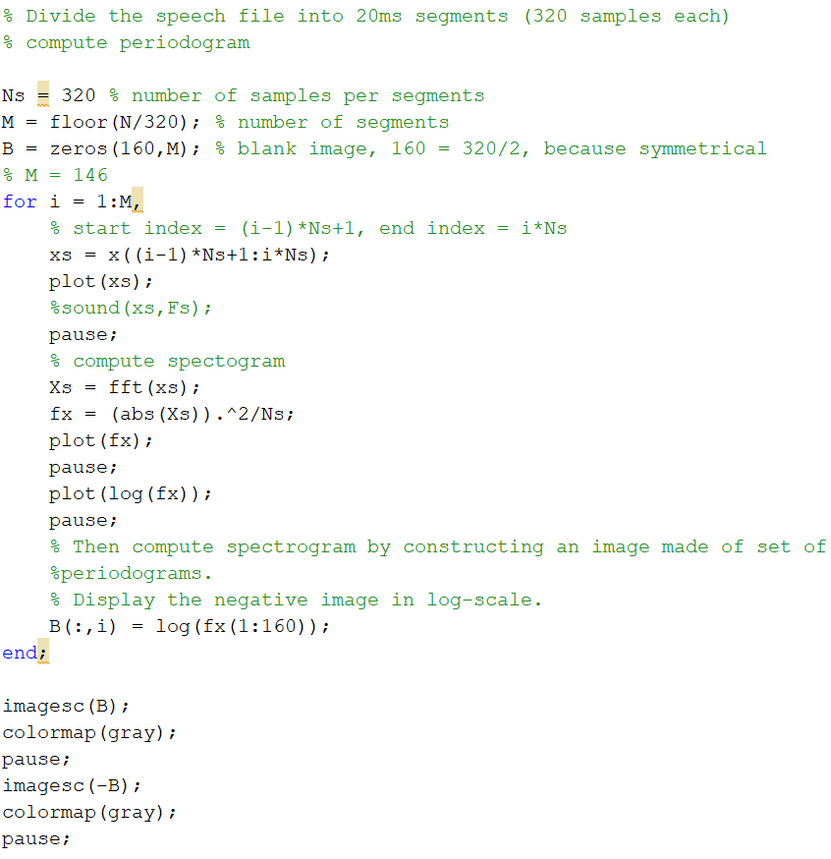

Plot(xs)
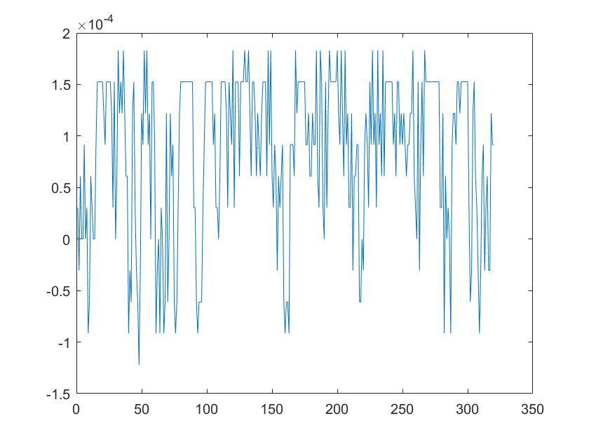

Log(fx)

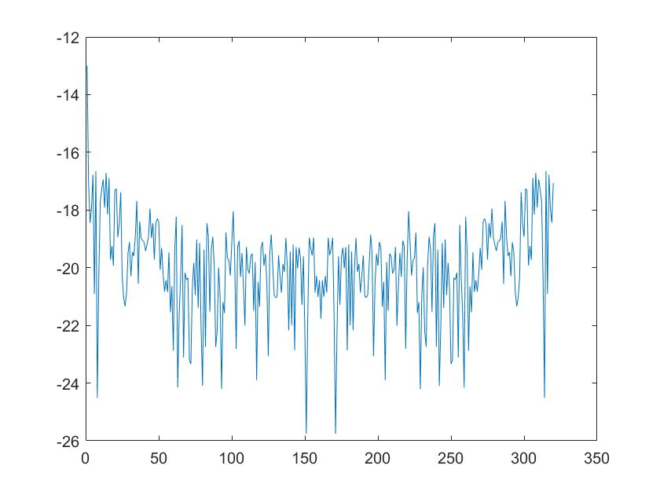

Imagesc(B)

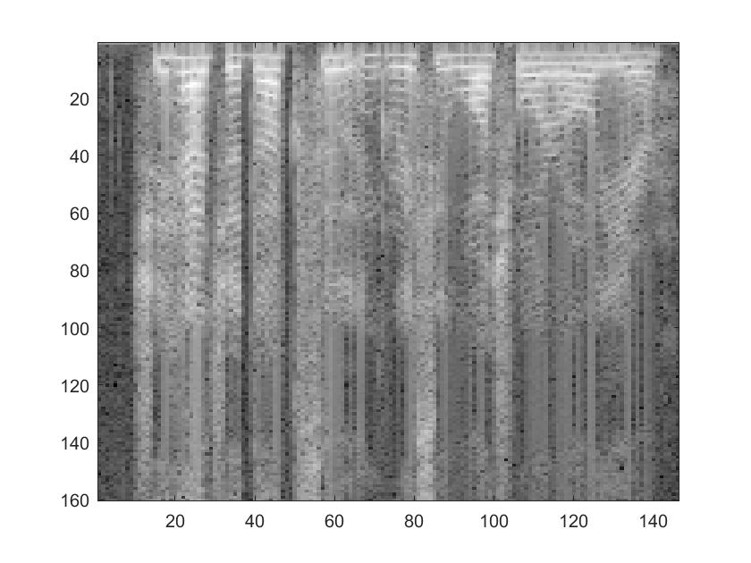

Imagesc(-B)

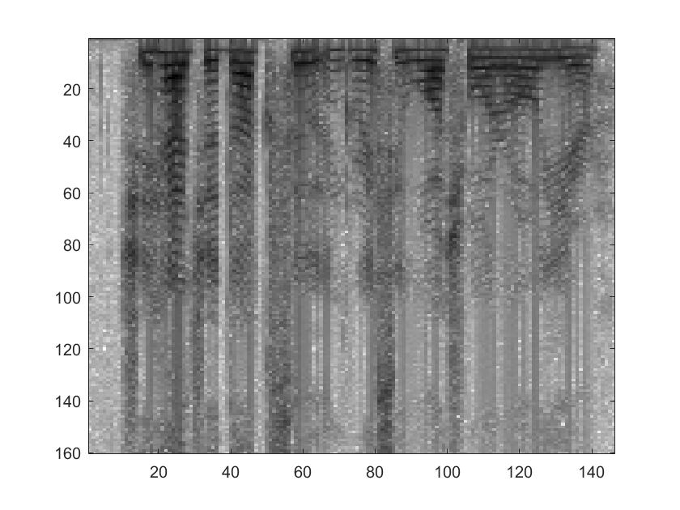
The negative image in log-scale is the power spectrum of the original signal. The darker area is showing the higher energy.

- Additional homework, hamming window.

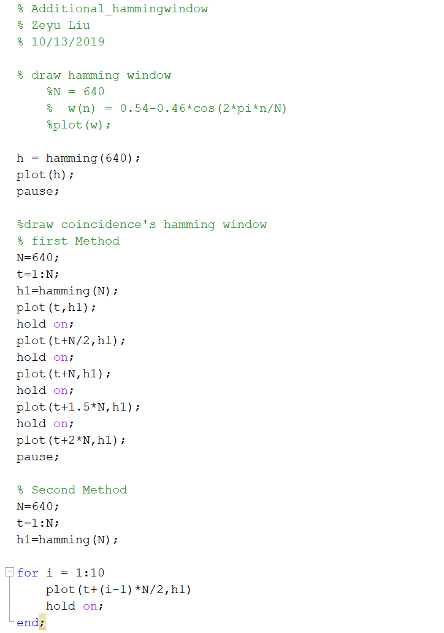

hamming window and coincidence’s hamming window

